**PSG COLLEGE OF TECHNOLOGY**

**DEPARTMENT OF APPLIED MATHEMATICS AND COMPUTATIONAL SCIENCES**

**VI SEM – M.Sc SOFTWARE SYSTEMS**

**15XW66 PRINCIPLES OF COMPILER DESIGN LAB**

**LEX TOOL -WORKSHEET – 5**

Using following NFA check whether the input string abbba is valid or not.

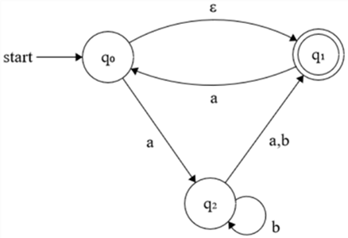

Using following NFA check whether the input string baacaa is valid or not.

